Ismael “Melo” Moreno is an Afro-descendant Jesuit priest in northern Honduras. He is known as Father Melo, reflecting his warm and charismatic personality. For the last 20 years he has been the leader of two social action projects of the Society of Jesus in Honduras: Radio Progreso, and ERIC, who provide accurate real-time reporting and human rights observers/mediators. Radio Progreso is broadcast from El Progreso, with transmission in San Pedro Sula and also Tegucigalpa, somewhat similar to the Pacifica radio stations in the U.S.
In 2015 Father Melo received the Rafto Prize, created in honor of a Norwegian human rights activist and in 2016 he was asked by students at the National University of Honduras (UNAH) to negotiate on their behalf for grievances against the administration. Father Melo worked closely with Berta Caceres, the environmental heroine who was assassinated in 2016. Father Melo and his colleagues have received numerous death threats and he is number two on a recently published assassination list of 13 social justice leaders.
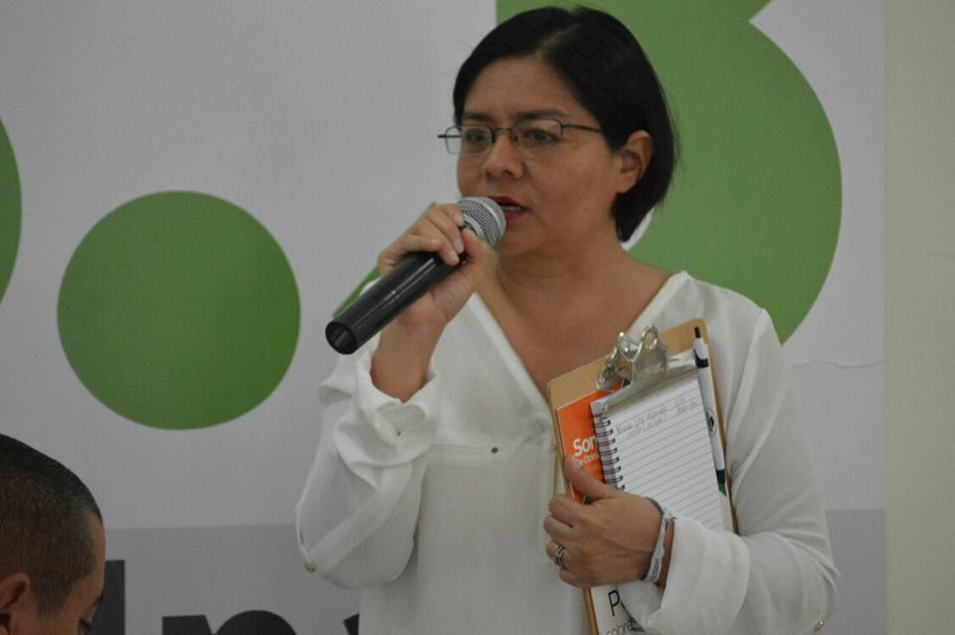
Karla Rivas, is a journalist with a degree from the Universidad Nacional Autónoma of Honduras. She coordinated the news department of Radio Progreso from 2002 to 2012. She has facilitated training processes in radio and analysis of context. In 2011 she received the Peter Mackler Award for Radio Progreso from the Global Media Forum and Reporters without Borders for ethical and courageous journalism. As part of the area of Investigation and Human Rights of the Reflection, Investigation and Communication Team (ERIC) - Radio Progreso, she coordinates the Jesuit Network, Migrant in Honduras.

Dunia Aracely Pérez, feminist, human rights defender and attorney with the Reflection, Investigation and Communication Team (ERIC) and Radio Progreso, both Jesuit missions in Honduras. In the area of Investigation and Human Rights, she accompanies and defends victims within the Inter American Human Rights System.

Rosa Maria Troches, is a defender of the human rights of Women and a Religious Sister of the Congregation of Notre Dame. In 1975, working in the Catholic parish of Juticalpa, Rosa Maria witnessed one of the worst massacres in the history of Honduras. The Honduran military, trained by US armed forces, came to her parish and kidnapped, tortured and killed Fathers Ivan Betancourt and Michael Jerome Zypher, the latter from Wisconsin. Rosa Maria was taken to prison. While jailed, she learned that 14 peasants, many of them religious leaders in their communities, had been killed as part of an effort to destroy the rural movement that fought for Agrarian Reform. Rosa Maria decided to join the Sisters of Notre Dame and commit her life to justice. She studied Liberation Theology with Father Gustavo Gutiérrez.
During the 1980’s, Rosa Maria accompanied thousands of refugees as a pastoral agent in Mesa Grande, Honduras. Following this intense period, Rosa Maria studied alternative medicine in Guatemala for four years. As a Sister of Notre Dame in El Progreso, Yoro, Rosa Maria upholds the rights of women and the poor in coordination with her community as well as the Jesuits and local and national social movements.

Ely Castro Rosales, was active in the student movement in high school, defending the human rights of students. He suffered persecution and a close family member was murdered. In the early 90’s he entered the Universidad Nacional Autónoma of Honduras where he studied Foreign Languages and joined the student movement at the university. Until 2000, he was a professor of literature and grammar in several bilingual schools in the city of Tegucigalpa. Currently he is a social and political activist with the Convergence Against Continuism in the department of Cortes, serving as a local coordinator and representative for the department to the Convergence at the national level.

Ángel Adelso Reyes is the parish coordinator, president of the health committee of San Nicolás, Santa Bárbara, member of serveral patronatos, secretary and president of the committee for ecclesiastical works of the catholic church San Nicolás; Coordinador of the Multi-Sector Network of vulnerable groups in San Nicolás, Santa Bárbara; part of a group of Friends of Radio Progreso - ECOS -that supports the promotion of the radio in the zone of the valleys through the club of Friends that makes an annual contribution in support of the radio.

